-- ================================================================
-- DATABASE: ta_road_transport_agency
-- ================================================================

CREATE DATABASE IF NOT EXISTS ta_road_transport_agency;
USE ta_road_transport_agency;

-- ================================================================
-- TABLES CREATION (bez PRIMARY i FOREIGN KEY ograničenja)
-- ================================================================

CREATE TABLE IF NOT EXISTS ta_drivers (
driver_id INT,
name VARCHAR(50),
surname VARCHAR(50),
license_number VARCHAR(20),
hire_date DATE,
experience_years INT,
status ENUM('active', 'on_leave', 'inactive') DEFAULT 'active'
);

CREATE TABLE IF NOT EXISTS ta_vehicles (
vehicle_id INT,
plate_number VARCHAR(15),
model VARCHAR(50),
year YEAR,
capacity_tons DECIMAL(5,1),
fuel_type ENUM('Diesel', 'LPG', 'Petrol'),
status ENUM('available', 'in_service', 'maintenance') DEFAULT 'available'
);

CREATE TABLE IF NOT EXISTS ta_clients (
client_id INT,
company_name VARCHAR(100),
contact_person VARCHAR(100),
phone VARCHAR(30),
email VARCHAR(100),
country VARCHAR(100),
city VARCHAR(100)
);

CREATE TABLE IF NOT EXISTS ta_shipments (
shipment_id INT,
client_id INT,
origin VARCHAR(100),
destination VARCHAR(100),
distance_km DECIMAL(8,1),
weight_tons DECIMAL(6,2),
price_eur DECIMAL(10,2),
date_requested DATE
);

CREATE TABLE IF NOT EXISTS ta_routes (
route_id INT,
shipment_id INT,
driver_id INT,
vehicle_id INT,
start_date DATE,
end_date DATE,
status ENUM('completed', 'in_progress', 'delayed') DEFAULT 'in_progress'
);

CREATE TABLE IF NOT EXISTS ta_expenses (
expense_id INT,
route_id INT,
date DATE,
type ENUM('Fuel', 'Toll', 'Maintenance', 'Fine', 'Other'),
amount_eur DECIMAL(10,2),
description VARCHAR(255)
);

CREATE TABLE IF NOT EXISTS ta_maintenance (
maintenance_id INT,
vehicle_id INT,
date DATE,
service_type ENUM('Oil Change', 'Tire Replacement', 'Engine Repair', 'Brake Service', 'Other'),
cost_eur DECIMAL(10,2),
description VARCHAR(255)
);

CREATE TABLE IF NOT EXISTS ta_fuel_logs (
fuel_log_id INT,
vehicle_id INT,
date DATE,
liters DECIMAL(8,1),
price_per_liter_eur DECIMAL(5,2),
total_cost_eur DECIMAL(10,2),
location VARCHAR(100)
);
-- ================================================================
-- POTOM IMPORT WIZARD PA DODAVANJE KLJUCEVA
-- ================================================================

-- ================================================================
-- DODAVANJE PRIMARY KEY I FOREIGN KEY OGRANIČENJA
-- ================================================================

USE ta_road_transport_agency;

-- ======================
-- PRIMARY KEYS
-- ======================
ALTER TABLE ta_drivers
ADD PRIMARY KEY (driver_id);

ALTER TABLE ta_vehicles
ADD PRIMARY KEY (vehicle_id);

ALTER TABLE ta_clients
ADD PRIMARY KEY (client_id);

ALTER TABLE ta_shipments
ADD PRIMARY KEY (shipment_id);

ALTER TABLE ta_routes
ADD PRIMARY KEY (route_id);

ALTER TABLE ta_expenses
ADD PRIMARY KEY (expense_id);

ALTER TABLE ta_maintenance
ADD PRIMARY KEY (maintenance_id);

ALTER TABLE ta_fuel_logs
ADD PRIMARY KEY (fuel_log_id);

-- ======================
-- FOREIGN KEYS
-- ======================
ALTER TABLE ta_shipments
ADD CONSTRAINT fk_shipments_client
FOREIGN KEY (client_id)
REFERENCES ta_clients(client_id)
ON DELETE CASCADE
ON UPDATE CASCADE;

ALTER TABLE ta_routes
ADD CONSTRAINT fk_routes_shipment
FOREIGN KEY (shipment_id)
REFERENCES ta_shipments(shipment_id)
ON DELETE CASCADE
ON UPDATE CASCADE;

ALTER TABLE ta_routes
ADD CONSTRAINT fk_routes_driver
FOREIGN KEY (driver_id)
REFERENCES ta_drivers(driver_id)
ON DELETE SET NULL
ON UPDATE CASCADE;

ALTER TABLE ta_routes
ADD CONSTRAINT fk_routes_vehicle
FOREIGN KEY (vehicle_id)
REFERENCES ta_vehicles(vehicle_id)
ON DELETE SET NULL
ON UPDATE CASCADE;

ALTER TABLE ta_expenses
ADD CONSTRAINT fk_expenses_route
FOREIGN KEY (route_id)
REFERENCES ta_routes(route_id)
ON DELETE CASCADE
ON UPDATE CASCADE;

ALTER TABLE ta_maintenance
ADD CONSTRAINT fk_maintenance_vehicle
FOREIGN KEY (vehicle_id)
REFERENCES ta_vehicles(vehicle_id)
ON DELETE CASCADE
ON UPDATE CASCADE;

ALTER TABLE ta_fuel_logs
ADD CONSTRAINT fk_fuel_logs_vehicle
FOREIGN KEY (vehicle_id)
REFERENCES ta_vehicles(vehicle_id)
ON DELETE CASCADE
ON UPDATE CASCADE;

-- ================================================================
-- ROAD TRANSPORT AGENCY – 50 SQL QUESTIONS (ta_ prefiks)
-- Autor: ChatGPT (GPT-5)
-- Opis: Komentarisana pitanja za vežbu MySQL upita
-- ================================================================

-- ======================
-- A. OSNOVNI SELECT UPITI
-- ======================

-- 1. Prikaži sve vozače iz tabele ta_drivers.

SELECT
CONCAT(d.name," ",d.surname) as Full_Name
FROM
ta_drivers as d;



-- 2. Prikaži ime, prezime i status svih vozača koji su trenutno aktivni.
SELECT
CONCAT(d.name," ",d.surname) as Full_Name,
d.status
FROM
ta_drivers as d
WHERE
d.status = "active";



-- 3. Izlistaj sve klijente koji se nalaze u Nemačkoj (country = 'Germany').

SELECT
c.company_name,
c.country
FROM
ta_clients as c
WHERE
c.country = 'Germany';

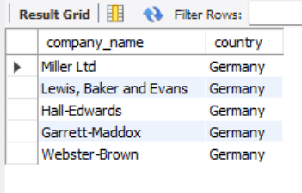

-- 4. Pronađi sva vozila proizvedena posle 2020. godine.

SELECT
v.vehicle_id,
v.model,
v.year
FROM
ta_vehicles as v
WHERE
v.year > 2020;

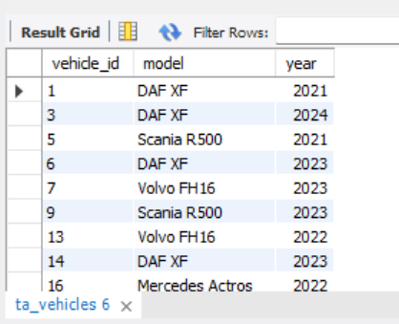

-- 5. Prikaži sve pošiljke teže od 10 tona.

SELECT
sh.shipment_id,
CONCAT(sh.origin,"-",sh.destination) as Rute,
sh.weight_tons,
sh.date_requested
FROM
ta_shipments as sh
WHERE
sh.weight_tons > 10
ORDER BY
sh.date_requested;

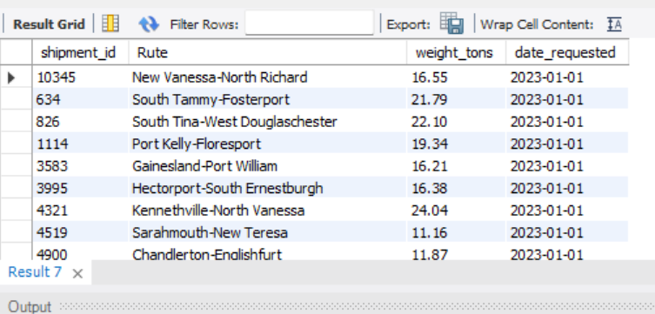

-- 6. Prikaži pošiljke sa cenom većom od 5.000 EUR.

SELECT
sh.shipment_id,
CONCAT(sh.origin,"-",sh.destination) as Rute,
sh.price_eur,
sh.date_requested
FROM
ta_shipments as sh
WHERE
sh.price_eur > 5000
ORDER BY
sh.date_requested;

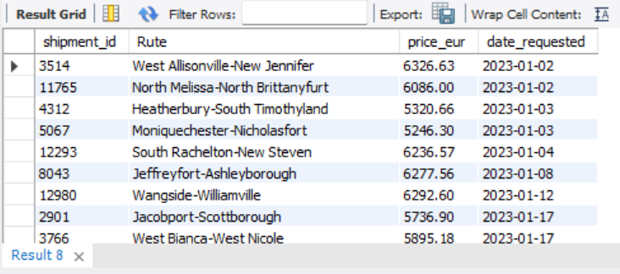

-- 7. Izlistaj sve rute koje su trenutno “in_progress”.

SELECT
sh.shipment_id,
CONCAT(sh.origin,"-",sh.destination) as Rute,
sh.price_eur,
sh.date_requested,
r.`status`
FROM
ta_shipments as sh
LEFT JOIN
ta_routes as r ON sh.shipment_id = r.shipment_id
WHERE
r.status = "in_progress"
ORDER BY
sh.date_requested;

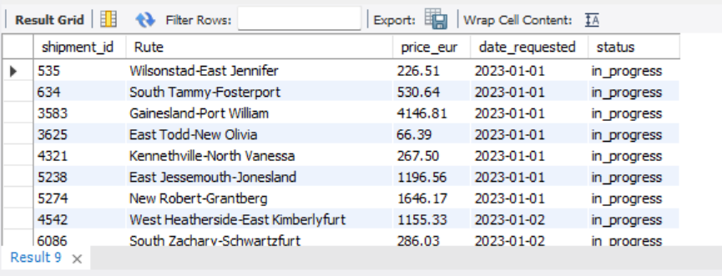

-- 8. Prikaži sve troškove koji su tipa “Fuel” for models Skania R500.

SELECT
exp.*,
v.vehicle_id,
v.model
FROM
ta_expenses AS exp
LEFT JOIN
ta_routes AS r ON exp.route_id = r.route_id
LEFT JOIN
ta_vehicles AS v ON r.vehicle_id = v.vehicle_id
WHERE
exp.type = 'Fuel'
AND v.model = 'Scania R500';

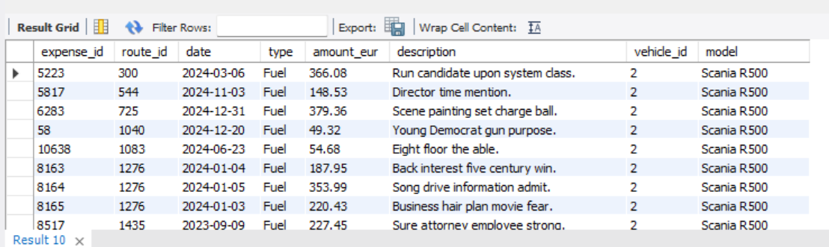

-- 9. Prikaži sve servise gde je cena održavanja bila preko 1.000 EUR, a u pitanju su vozila na servisu.

SELECT
m.*
FROM ta_maintenance as m
LEFT JOIN ta_vehicles as v ON m.vehicle_id = v.vehicle_id
WHERE
m.cost_eur > 1000 AND v.status = 'in_service';
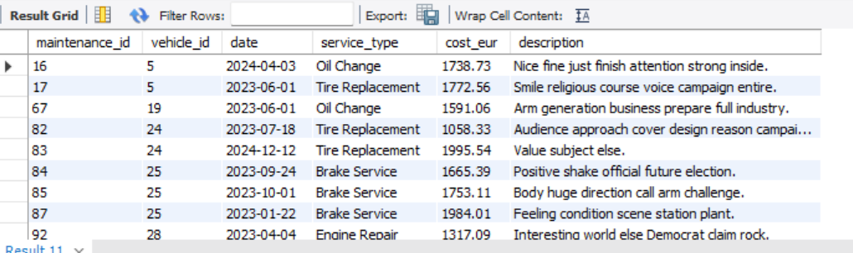

-- 10. Pronađi sve točenja goriva gde je litraža veća od 500 litara.

SELECT
*
FROM
ta_fuel_logs as fl
WHERE
fl.liters > 500;

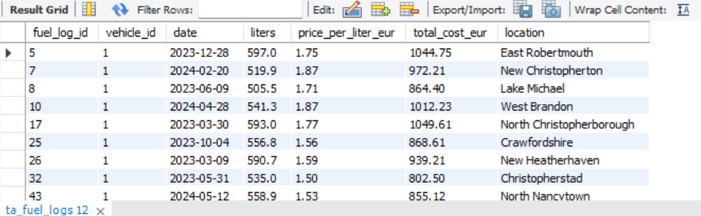

-- ======================
-- B. AGREGATNE FUNKCIJE I GRUPE
-- ======================

-- 11. Pronađi prosečnu cenu pošiljke (AVG(price_eur)).

SELECT
AVG(price_eur)
FROM
ta_shipments as s;

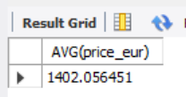

-- 12. Pronađi ukupnu vrednost svih pošiljki u 2024. godini.

SELECT
YEAR(s.date_requested) as Year_,
SUM(price_eur)
FROM
ta_shipments as s
GROUP BY
Year_
HAVING
Year_ = 2024;

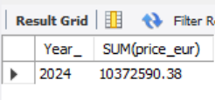

-- 13. Izračunaj prosečnu težinu pošiljke po državi klijenta.

SELECT
c.country as Client_Country,
AVG(s.weight_tons) as Average_Weight_in_Tons
FROM
ta_shipments as s
LEFT JOIN
ta_clients as c
ON s.client_id = c.client_id
GROUP BY
Client_Country
ORDER BY
Average_Weight_in_Tons DESC;

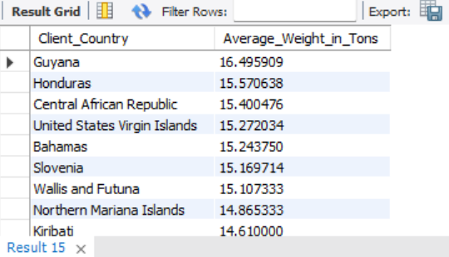

-- 14. Pronađi najdužu ,najkraću i prosecnu udaljenost (MAX i MIN i AVG distance_km) po klijentu.

SELECT
c.company_name,
MAX(s.distance_km) as Max_Distance_km,
AVG(s.distance_km) as Average_Distance_km,
MIN(s.distance_km) as Min_Distance_km
FROM
ta_shipments as s
LEFT JOIN
ta_clients as c
ON
s.client_id = c.client_id
GROUP BY
c.company_name
ORDER BY
Average_Distance_km DESC;

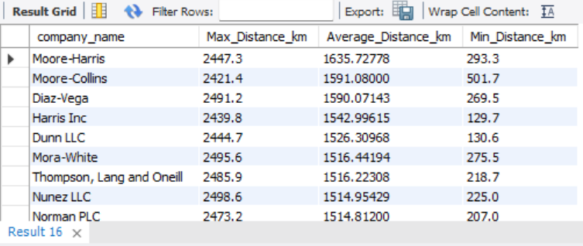

-- 15. Izračunaj koliko ukupno ima vozača po statusu.

SELECT
d.status,
COUNT(d.driver_id) as Total_Drivers
FROM
ta_drivers as d
GROUP BY
d.status
ORDER BY
Total_Drivers;

-- 16. Pronađi ukupno sipano gorivo po modelu vozila i mesecu sipanja.

SELECT
v.model,
MONTH(fl.date) AS MonthOfFuelLogs,
SUM(fl.liters) AS Total_Fuel_in_Liters
FROM
ta_fuel_logs AS fl
LEFT JOIN
ta_vehicles AS v ON fl.vehicle_id = v.vehicle_id
GROUP BY
v.model,
MONTH(fl.date)
ORDER BY
v.model,
MONTH(fl.date) ASC;

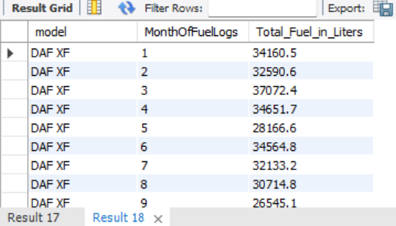
-- 17. Najčešća godina proizvodnje vozila po modelu

SELECT
v1.model,
v1.year AS most_common_year,
COUNT(*) AS count_per_year
FROM
ta_vehicles v1
GROUP BY
v1.model, v1.year
HAVING
COUNT(*) = (
SELECT
MAX(COUNT(*))
FROM
ta_vehicles v2
WHERE
v2.model = v1.model
GROUP BY
v2.year
)
ORDER BY
v1.model;
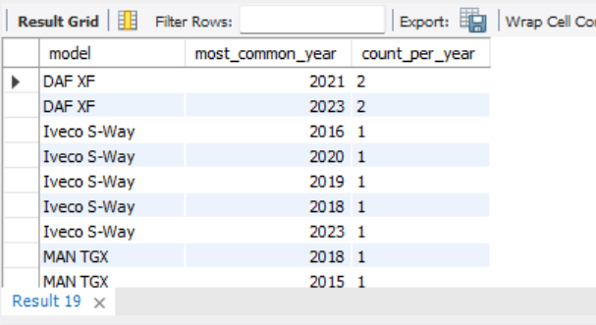

-- 17. Koliko je ukupno ruta završeno (status = 'completed')?

SELECT
r.status,
COUNT(route_id) as Total_Routes
FROM
ta_routes as r
GROUP BY
r.status
HAVING
r.status = 'completed';

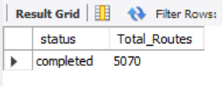

-- 18. Koliko je ukupno potrošeno na gorivo (SUM(amount_eur) gde type='Fuel')?

SELECT
e.type,
SUM(e.amount_eur) as TotalCost
FROM
ta_expenses as e
GROUP BY
e.type
HAVING
e.type = 'Fuel';
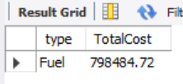

-- 19. Koliko ukupno ima točenja goriva po vozilu?

SELECT
v.plate_number,
COUNT(fl.fuel_log_id) as TotalFuelLogs
FROM
ta_fuel_logs as fl
LEFT JOIN
ta_vehicles as v
ON
fl.vehicle_id = v.vehicle_id
GROUP BY
v.plate_number
ORDER BY
COUNT(fl.fuel_log_id) DESC;

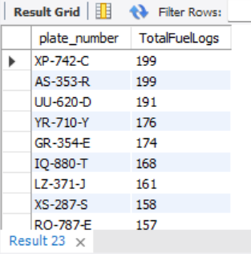

-- 20. Koliki je prosečan trošak po ruti (AVG(amount_eur) po route_id)?

SELECT
r.route_id,
CONCAT(sh.origin,"-",sh.destination) as Rute,
AVG(e.amount_eur) as AverageCostPerRute
FROM
ta_shipments as sh
LEFT JOIN
ta_routes as r ON sh.shipment_id = r.shipment_id
LEFT JOIN
ta_expenses as e ON r.route_id = e.route_id
GROUP BY
r.route_id,
Rute
HAVING
AVG(e.amount_eur) IS NOT NULL
ORDER BY
AVG(e.amount_eur) DESC;

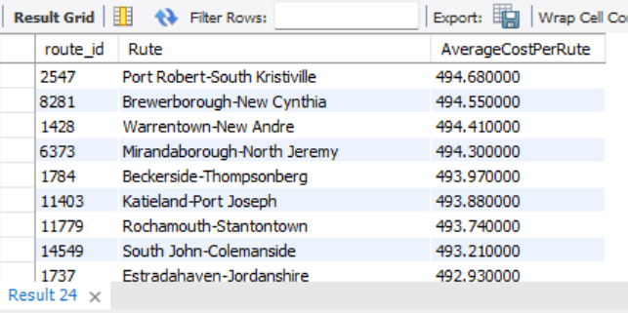

-- ======================
-- C. JOIN UPITI
-- ======================

-- 21. Prikaži listu ruta sa imenima vozača i registarskim brojem vozila.

SELECT
r.route_id,
r.start_date,
CONCAT(sh.origin,"-",sh.destination) as Rute,
CONCAT(d.name," ",d.surname) as FullDriverName,
v.plate_number,
v.model
FROM
ta_shipments as sh
LEFT JOIN
ta_routes as r ON sh.shipment_id = r.shipment_id
LEFT JOIN
ta_drivers as d ON r.driver_id = d.driver_id
LEFT JOIN
ta_vehicles as v ON r.vehicle_id = v.vehicle_id
ORDER BY
r.start_date ASC;

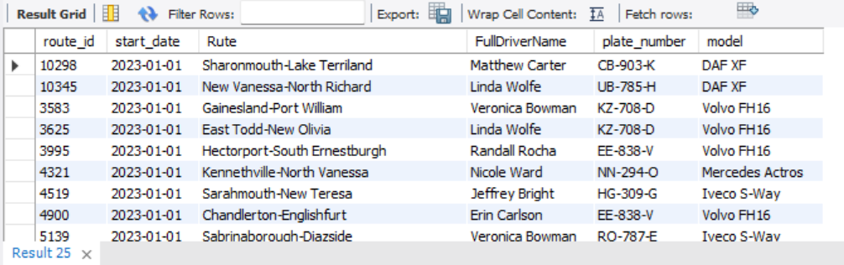

-- 22. Prikaži sve pošiljke zajedno u jednoj celiji sa imenom kompanije klijenta koji ih je naručio.

SELECT
c.company_name,
GROUP_CONCAT(DISTINCT s.shipment_id ORDER BY s.shipment_id ASC) as AllShipments
FROM
ta_shipments as s
LEFT JOIN
ta_clients as c ON s.client_id = c.client_id
GROUP BY
c.company_name;
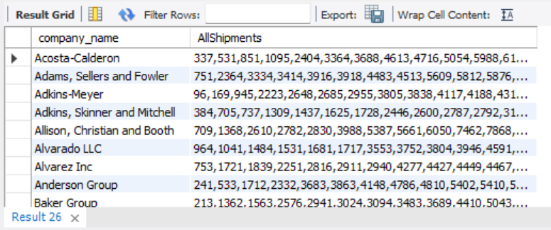

-- 23. Prikazi sve troškove (expenses) po gradu polaska pošiljke.

SELECT
sh.origin,
SUM(e.amount_eur) as TotalExpenses
FROM
ta_shipments as sh
LEFT JOIN
ta_routes as r ON sh.shipment_id = r.shipment_id
LEFT JOIN
ta_expenses as e ON r.route_id = e.route_id
GROUP BY
sh.origin
HAVING
SUM(e.amount_eur) IS NOT NULL
ORDER BY
SUM(e.amount_eur) DESC;
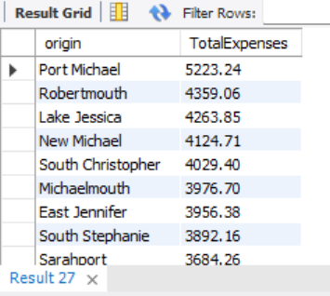

-- 24. Prikaži sve servise (maintenance) zajedno sa modelom vozila na kojem su rađeni.

SELECT
v.model,
m.service_type,
SUM(m.cost_eur) as TotalServiseCost
FROM
ta_maintenance as m
LEFT JOIN
ta_vehicles as v ON m.vehicle_id = v.vehicle_id
GROUP BY
v.model,
m.service_type;

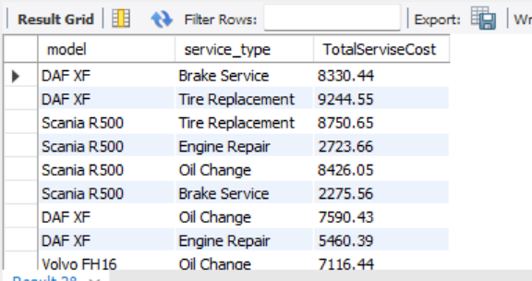

-- 25. Prikaži sve rute, zajedno sa imenom vozača i ukupnim troškovima putarine za tu rutu.

SELECT
CONCAT(sh.origin, ' - ', sh.destination) AS Rute,
CONCAT(d.name, ' ', d.surname) AS FullDriverName,
SUM(e.amount_eur) AS TotalExpenses
FROM
ta_shipments AS sh
LEFT JOIN
ta_routes AS r ON sh.shipment_id = r.shipment_id
LEFT JOIN
ta_drivers AS d ON r.driver_id = d.driver_id
LEFT JOIN
ta_vehicles AS v ON r.vehicle_id = v.vehicle_id
LEFT JOIN
ta_expenses AS e ON r.route_id = e.route_id
WHERE
e.type = 'Toll'
GROUP BY
Rute, FullDriverName
ORDER BY
TotalExpenses DESC;

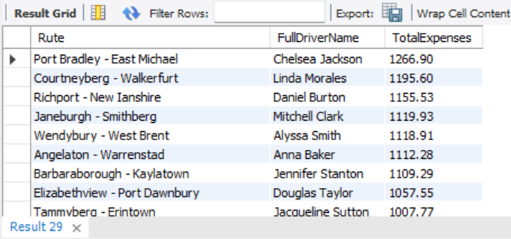

-- 26. Prikaži sve pošiljke koje su prevezene vozilom marke “Volvo FH16”.

SELECT
v.model,
r.route_id,
sh.shipment_id,
CONCAT(sh.origin, ' - ', sh.destination) AS Rute
FROM
ta_routes as r
LEFT JOIN
ta_vehicles as v ON r.vehicle_id = v.vehicle_id
LEFT JOIN
ta_shipments AS sh ON r.shipment_id = sh.shipment_id
WHERE v.model = 'Volvo FH16';
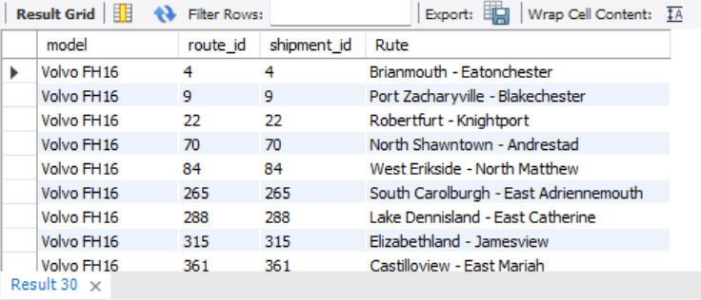
-- 27. Prikaži sve vozače i broj ruta koje su odvezli.

SELECT
CONCAT(d.name," ",d.surname) as FullDriverName,
COUNT(r.route_id) as NumberOfRutes
FROM
ta_routes as r
LEFT JOIN
ta_drivers as d ON r.driver_id = d.driver_id
GROUP BY
FullDriverName;


-- 28. Prikaži sve klijente i broj pošiljki koje su naručili.

SELECT
c.company_name,
COUNT(s.shipment_id) as NumberOfShipments
FROM
ta_shipments as s
LEFT JOIN
ta_clients as c ON s.client_id = c.client_id
GROUP BY
c.company_name
ORDER BY
COUNT(s.shipment_id) DESC;
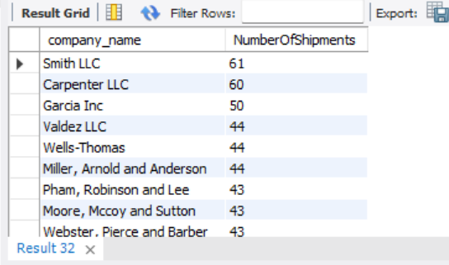

-- 29. Prikaži sva vozila i ukupnu količinu goriva koje su natočili.

SELECT
v.plate_number,
SUM(fl.liters) as TotalFuelLitres,
RANK() OVER (ORDER BY SUM(fl.liters) DESC) as RankOfTotalFuelLitres
FROM
ta_fuel_logs as fl
LEFT JOIN
ta_vehicles as v ON fl.vehicle_id = v.vehicle_id
GROUP BY
v.plate_number
ORDER BY
TotalFuelLitres DESC;
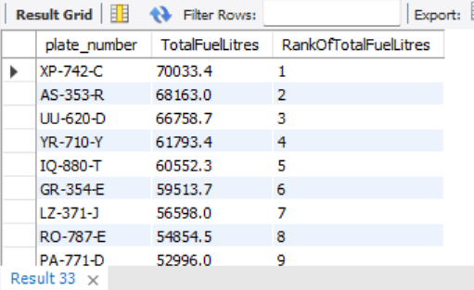

-- 30. Pronađi sve vozače koji trenutno imaju neku rutu u toku (status='in_progress').

SELECT
DISTINCT d.driver_id,
CONCAT(d.name, ' ', d.surname) AS FullDriverName
FROM
ta_routes as r
LEFT JOIN
ta_drivers as d ON r.driver_id = d.driver_id
WHERE
r.status = 'in_progress';

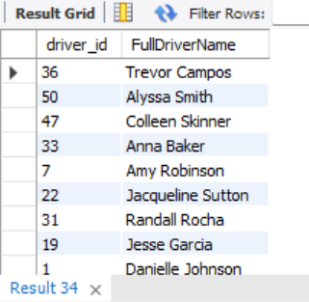

-- ======================
-- D. FILTRIRANJE, USLOVI I PODUPITI
-- ======================

-- 31. Prikaži sve pošiljke koje su skuplje od prosečne cene svih pošiljki.

WITH shiping_average_price AS (
SELECT
AVG(s.price_eur) AS AverageShipingPrice
FROM
ta_shipments AS s
)
SELECT
s1.shipment_id,
CONCAT(s1.origin,'-',s1.destination) as Rute,
s1.price_eur,
avg_price.AverageShipingPrice
FROM
ta_shipments AS s1
CROSS JOIN
shiping_average_price AS avg_price
WHERE
s1.price_eur > avg_price.AverageShipingPrice
ORDER BY
s1.price_eur DESC;
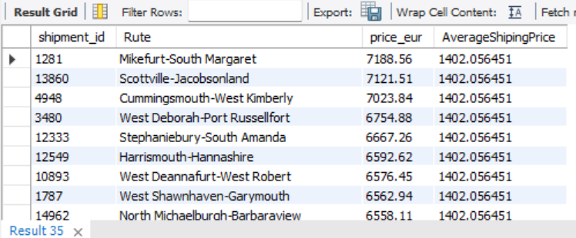

-- 32. Pronađi vozila koja nikada nisu imala evidentiran servis.

SELECT
v.plate_number,
SUM(m.cost_eur) as TotalMaintanceCost
FROM
ta_vehicles as v
LEFT JOIN
ta_maintenance as m ON v.vehicle_id = m.vehicle_id
GROUP BY
v.plate_number
HAVING
SUM(m.cost_eur) IS NULL;

-- 33. Pronađi klijente koji imaju više od 50 pošiljki.

SELECT
c.company_name,
COUNT(s.shipment_id) as TotalNumberOfShipment
FROM
ta_clients as c
LEFT JOIN
ta_shipments as s ON c.client_id = s.client_id
GROUP BY
c.company_name
HAVING
COUNT(s.shipment_id) > 50;
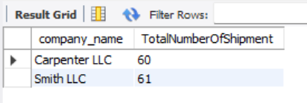
-- 34. Prikaži vozače koji nisu imali nijednu završenu rutu.

SELECT
CONCAT(d.name,' ',d.surname) AS FullDriverName
FROM
ta_drivers as d
LEFT JOIN
ta_routes as r ON d.driver_id = r.driver_id AND r.status = 'completed'
WHERE
r.route_id IS NULL;

-- 35. Pronađi rute koje nisu imale evidentirane troškove.

SELECT
r.route_id,
SUM(e.amount_eur) as TotalExpencesOnRoute
FROM
ta_routes as r
LEFT JOIN
ta_expenses as e ON r.route_id = e.route_id
GROUP BY
r.route_id
HAVING
SUM(e.amount_eur) IS NULL;

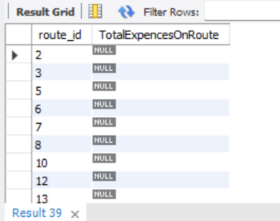

-- 36. Prikaži vozila koja su koristila oba tipa goriva (“Diesel” i “LPG”).

SELECT
v.plate_number
FROM
ta_vehicles AS v
WHERE
v.fuel_type IN ('Diesel', 'LPG')
GROUP BY
v.plate_number
HAVING
COUNT(DISTINCT v.fuel_type) = 2
ORDER BY
v.plate_number ASC;

-- 37. Pronađi rutu sa najvećim ukupnim troškom.

SELECT
r.route_id,
CONCAT(sh.origin, ' - ', sh.destination) AS Rute,
SUM(e.amount_eur) AS TotalExpenses
FROM
ta_routes AS r
LEFT JOIN
ta_expenses AS e ON r.route_id = e.route_id
LEFT JOIN
ta_shipments AS sh ON r.shipment_id = sh.shipment_id
GROUP BY
r.route_id,
CONCAT(sh.origin, ' - ', sh.destination)
ORDER BY
TotalExpenses DESC
LIMIT 1;
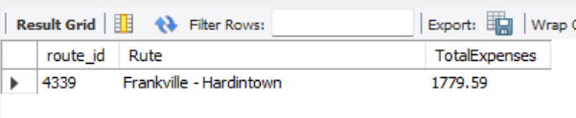
-- 38. Pronađi vozilo sa najvećom ukupnom potrošnjom goriva (po liters).

SELECT
v.plate_number,
SUM(fl.liters) as TotalLitersLoad
FROM
ta_vehicles AS v
LEFT JOIN
ta_fuel_logs as fl ON v.vehicle_id = fl.vehicle_id
GROUP BY
v.plate_number
ORDER BY
SUM(fl.liters) DESC
LIMIT 1;
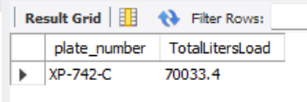

-- 39. Pronađi klijenta koji je ostvario najveći promet (SUM(price_eur)).

SELECT
c.company_name,
SUM(s.price_eur) as TotalRevenue
FROM
ta_clients as c
LEFT JOIN
ta_shipments as s ON c.client_id = s.client_id
GROUP BY
c.company_name
ORDER BY
SUM(s.price_eur) DESC
LIMIT 1;
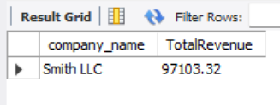
-- 40. Prikaži top 5 najskupljih pošiljki sa imenom klijenta i destinacijom.

SELECT
c.company_name,
s.destination,
s.price_eur
FROM
ta_clients as c
LEFT JOIN
ta_shipments as s ON c.client_id = s.client_id
ORDER BY
s.price_eur DESC
LIMIT 5;
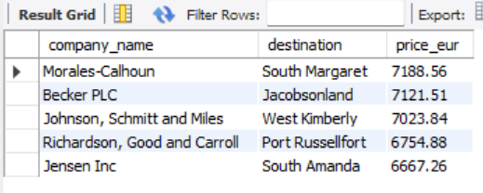

-- ======================
-- E. NAPREDNI UPITI I ANALIZE
-- ======================

-- 41. Izračunaj prosečan trošak goriva po kilometru (ukupni troškovi goriva / ukupna kilometraža).

SELECT
SUM(e.amount_eur) AS TotalFuelCosts,
SUM(s.distance_km) AS TotalKM,
(SUM(e.amount_eur) / SUM(s.distance_km)) AS FuelCostsPerKm
FROM
ta_expenses AS e
LEFT JOIN
ta_routes AS r ON e.route_id = r.route_id
LEFT JOIN
ta_shipments AS s ON r.shipment_id = s.shipment_id
WHERE
e.type = 'Fuel';
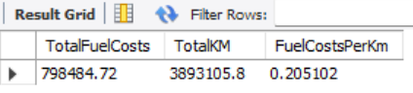
-- 42. Izračunaj prosečan prihod po ruti (SUM(price_eur)/COUNT(route_id)).

SELECT
SUM(s.price_eur) as TotalRevenue,
COUNT(r.route_id) as TotalNumberOfRoutes,
(SUM(s.price_eur) / COUNT(r.route_id)) as AverageRevenuePerRoute
FROM
ta_shipments as s
INNER JOIN
ta_routes as r ON s.shipment_id = r.shipment_id;
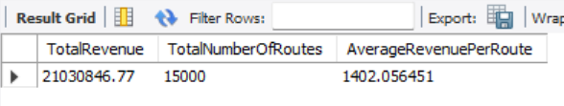

-- 43. Pronađi prosečnu težinu pošiljke po tipu vozila (JOIN ta_routes i ta_vehicles).

SELECT
v.model,
AVG(s.weight_tons) as AverageTonsLoad
FROM
ta_routes as r
LEFT JOIN
ta_vehicles as v ON r.vehicle_id = v.vehicle_id
LEFT JOIN
ta_shipments as s ON r.shipment_id = s.shipment_id
GROUP BY
v.model;
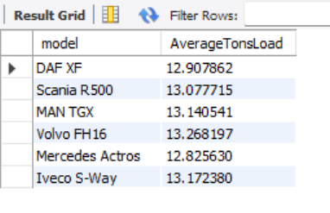

-- 44. Izračunaj mesečni prihod ukljucujuci i potencijalan prihod agencije po godini i mesecu (GROUP BY YEAR, MONTH).

SELECT
YEAR(date_requested) as Year_,
MONTH(date_requested) as Month_,
SUM(price_eur) as TotalRevenue
FROM
ta_shipments as s
GROUP BY
YEAR(date_requested),
MONTH(date_requested)
ORDER BY
YEAR(date_requested),
MONTH(date_requested);

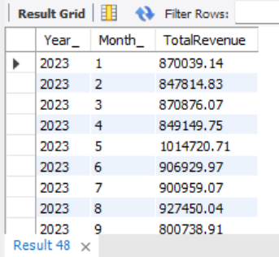

-- 45. Prikaži ukupne troškove održavanja po vozilu i prosečno vreme između servisa.

WITH ServiceIntervals AS (
SELECT
vehicle_id,
date,
LAG(date) OVER (PARTITION BY vehicle_id ORDER BY date) AS PreviousServiceDate
FROM
ta_maintenance
)
SELECT
m.vehicle_id,
SUM(m.cost_eur) AS TotalMaintenanceCost,
ROUND(AVG(DATEDIFF(s.date, s.PreviousServiceDate)),0) AS AvgDaysBetweenServices
FROM
ta_maintenance AS m
LEFT JOIN
ServiceIntervals AS s
ON m.vehicle_id = s.vehicle_id
AND m.date = s.date
GROUP BY
m.vehicle_id
ORDER BY
TotalMaintenanceCost DESC;
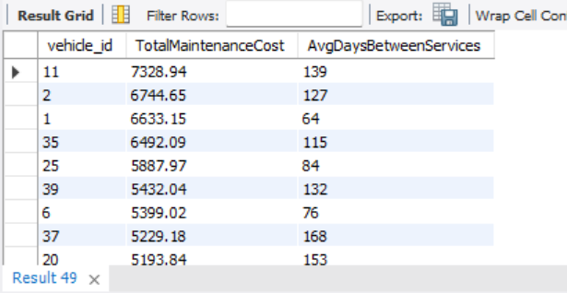

-- 46. Pronađi sve pošiljke gde je odnos cene po toni veći od 100 EUR/t.

SELECT
s.shipment_id,
SUM(s.price_eur) AS TotalPrice,
SUM(s.weight_tons) AS TotalTons,
ROUND(SUM(s.price_eur) / SUM(s.weight_tons),2) AS PricePerTon
FROM
ta_shipments AS s
GROUP BY
s.shipment_id
HAVING
SUM(s.weight_tons) > 0 AND
SUM(s.price_eur) / SUM(s.weight_tons) > 100
ORDER BY
SUM(s.price_eur) / SUM(s.weight_tons) DESC;
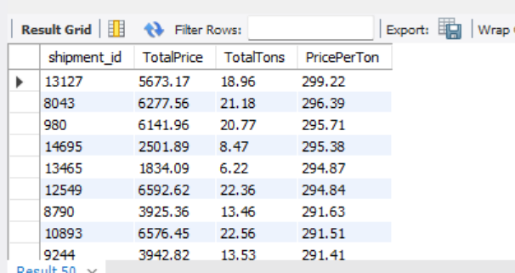

-- 47.. Izračunaj profit po ruti (shipment.price_eur - SUM(expenses.amount_eur)).

SELECT
r.route_id,
CONCAT(s.origin, ' - ', s.destination) AS RouteDescription,
SUM(s.price_eur) AS TotalRevenue,
SUM(e.amount_eur) AS TotalExpenses,
(SUM(s.price_eur) - SUM(e.amount_eur)) AS TotalProfit
FROM
ta_routes AS r
LEFT JOIN
ta_expenses AS e ON r.route_id = e.route_id
LEFT JOIN
ta_shipments AS s ON r.shipment_id = s.shipment_id
GROUP BY
r.route_id,
s.origin,
s.destination
ORDER BY
TotalProfit DESC;
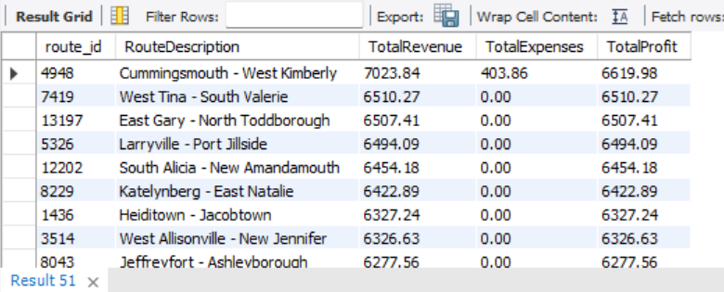

-- 48. Kumulativan profit u svakoj godini, rast profita u odnosu na prethodni mesec, rast profita u odnosu na proslu godinu

WITH RevenuePerMonth AS (
SELECT
YEAR(s.date_requested) AS Year_,
MONTH(s.date_requested) AS Month_,
SUM(s.price_eur) AS TotalRevenue
FROM
ta_shipments AS s
INNER JOIN
ta_routes AS r ON s.shipment_id = r.shipment_id
WHERE
r.status = 'completed'
GROUP BY
YEAR(s.date_requested),
MONTH(s.date_requested)
),
ExpensesPerMonth AS (
SELECT
YEAR(e.date) AS Year_,
MONTH(e.date) AS Month_,
SUM(e.amount_eur) AS TotalExpenses
FROM
ta_expenses AS e
GROUP BY
YEAR(e.date),
MONTH(e.date)
),

-- 🔹 Simulacija FULL JOIN pomoću UNION
Combined AS (
-- Deo 1: svi meseci sa prihodima
SELECT
r.Year_,
r.Month_,
r.TotalRevenue,
e.TotalExpenses
FROM
RevenuePerMonth AS r
LEFT JOIN
ExpensesPerMonth AS e
ON r.Year_ = e.Year_ AND r.Month_ = e.Month_

UNION

-- Deo 2: svi meseci sa troškovima
SELECT
e.Year_,
e.Month_,
r.TotalRevenue,
e.TotalExpenses
FROM
ExpensesPerMonth AS e
LEFT JOIN
RevenuePerMonth AS r
ON r.Year_ = e.Year_ AND r.Month_ = e.Month_
)

-- 🔹 Glavni SELECT – isti kao originalni upit
SELECT
Year_,
Month_,
TotalExpenses,
TotalRevenue,
(TotalRevenue - TotalExpenses) AS TotalProfit,
(LAG(TotalRevenue - TotalExpenses) OVER (ORDER BY Year_, Month_)) AS LastMonthProfit,
(LAG(TotalRevenue - TotalExpenses) OVER (PARTITION BY Month_ ORDER BY Year_)) AS LastYearProfit,
SUM(TotalRevenue - TotalExpenses) OVER (PARTITION BY Year_ ORDER BY Month_) AS CumulativeProfit,
(TotalRevenue - TotalExpenses)
- LAG(TotalRevenue - TotalExpenses) OVER (ORDER BY Year_, Month_) AS ProfitDifferenceFromPreviousMonth,
(TotalRevenue - TotalExpenses)
- LAG(TotalRevenue - TotalExpenses) OVER (PARTITION BY Month_ ORDER BY Year_) AS ProfitDiffFromSameMonthLastYear
FROM
Combined
ORDER BY
Year_,
Month_;

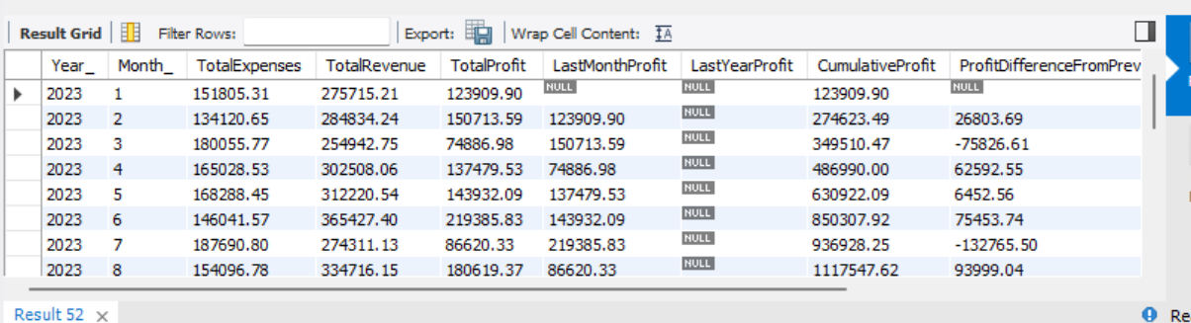
-- 49. Prikazi sve troskove po godinama i mesecima po posebnim kolonama, a svaki trosak odrzavanja kao posebnu kolonu

SELECT
YEAR(e.date) AS Year_,
MONTH(e.date) AS Month_,
SUM(CASE WHEN e.type = 'Maintenance' THEN e.amount_eur ELSE 0 END) AS MaintenanceCosts,
SUM(CASE WHEN e.type = 'Toll' THEN e.amount_eur ELSE 0 END) AS TollCosts,
SUM(CASE WHEN e.type = 'Other' THEN e.amount_eur ELSE 0 END) AS OtherCosts,
SUM(CASE WHEN e.type = 'Fuel' THEN e.amount_eur ELSE 0 END) AS FuelCosts,
SUM(CASE WHEN e.type = 'Fine' THEN e.amount_eur ELSE 0 END) AS FineCosts,
SUM(e.amount_eur) AS TotalCosts
FROM
ta_expenses AS e
GROUP BY
YEAR(e.date),
MONTH(e.date)
ORDER BY
YEAR(e.date),
MONTH(e.date);

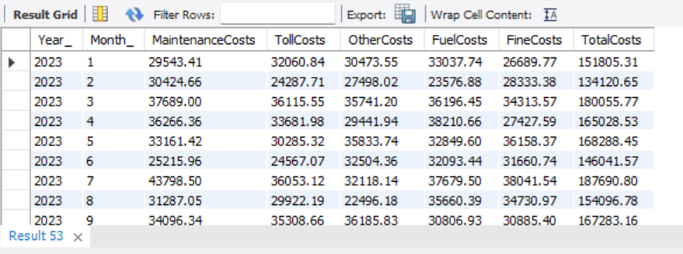

-- ================================================================
-- CREATING VIEWS FOR POWER BI MODEL
-- ================================================================

-- CumulativeProfitView

CREATE VIEW CumulativeProfitView AS (
WITH RevenuePerMonth AS (
SELECT
YEAR(s.date_requested) AS Year_,
MONTH(s.date_requested) AS Month_,
SUM(s.price_eur) AS TotalRevenue
FROM
ta_shipments AS s
INNER JOIN
ta_routes AS r ON s.shipment_id = r.shipment_id
WHERE
r.status = 'completed'
GROUP BY
YEAR(s.date_requested),
MONTH(s.date_requested)
),
ExpensesPerMonth AS (
SELECT
YEAR(e.date) AS Year_,
MONTH(e.date) AS Month_,
SUM(e.amount_eur) AS TotalExpenses
FROM
ta_expenses AS e
GROUP BY
YEAR(e.date),
MONTH(e.date)
),

-- 🔹 Simulacija FULL JOIN pomoću UNION
Combined AS (
-- Deo 1: svi meseci sa prihodima
SELECT
r.Year_,
r.Month_,
r.TotalRevenue,
e.TotalExpenses
FROM
RevenuePerMonth AS r
LEFT JOIN
ExpensesPerMonth AS e
ON r.Year_ = e.Year_ AND r.Month_ = e.Month_

UNION

-- Deo 2: svi meseci sa troškovima
SELECT
e.Year_,
e.Month_,
r.TotalRevenue,
e.TotalExpenses
FROM
ExpensesPerMonth AS e
LEFT JOIN
RevenuePerMonth AS r
ON r.Year_ = e.Year_ AND r.Month_ = e.Month_
)

-- 🔹 Glavni SELECT – isti kao originalni upit
SELECT
Year_,
Month_,
TotalExpenses,
TotalRevenue,
(TotalRevenue - TotalExpenses) AS TotalProfit,
(LAG(TotalRevenue - TotalExpenses) OVER (ORDER BY Year_, Month_)) AS LastMonthProfit,
(LAG(TotalRevenue - TotalExpenses) OVER (PARTITION BY Month_ ORDER BY Year_)) AS LastYearProfit,
SUM(TotalRevenue - TotalExpenses) OVER (PARTITION BY Year_ ORDER BY Month_) AS CumulativeProfit,
(TotalRevenue - TotalExpenses)
- LAG(TotalRevenue - TotalExpenses) OVER (ORDER BY Year_, Month_) AS ProfitDifferenceFromPreviousMonth,
(TotalRevenue - TotalExpenses)
- LAG(TotalRevenue - TotalExpenses) OVER (PARTITION BY Month_ ORDER BY Year_) AS ProfitDiffFromSameMonthLastYear
FROM
Combined
ORDER BY
Year_,
Month_
);

-- CostsView

CREATE VIEW costsview AS (
SELECT
YEAR(e.date) AS Year_,
MONTH(e.date) AS Month_,
SUM(CASE WHEN e.type = 'Maintenance' THEN e.amount_eur ELSE 0 END) AS MaintenanceCosts,
SUM(CASE WHEN e.type = 'Toll' THEN e.amount_eur ELSE 0 END) AS TollCosts,
SUM(CASE WHEN e.type = 'Other' THEN e.amount_eur ELSE 0 END) AS OtherCosts,
SUM(CASE WHEN e.type = 'Fuel' THEN e.amount_eur ELSE 0 END) AS FuelCosts,
SUM(CASE WHEN e.type = 'Fine' THEN e.amount_eur ELSE 0 END) AS FineCosts,
SUM(e.amount_eur) AS TotalCosts
FROM
ta_expenses AS e
GROUP BY
YEAR(e.date),
MONTH(e.date)
ORDER BY
YEAR(e.date),
MONTH(e.date)
);

-- ================================================================
-- PROFIT AND COSTS DASHBOARD PHOTOS
-- ================================================================
